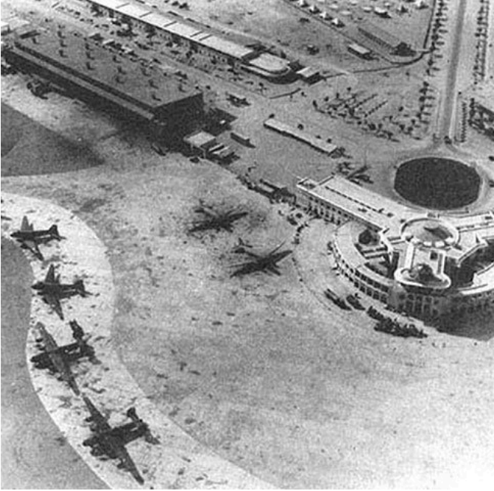
This picture is of Karachi airport back in 1943. This is the picture of busiest airport in Asia and a major hub for tourists. Before Dubai airport, Karachi airport served as the central point for all aircrafts to land and refuel.

